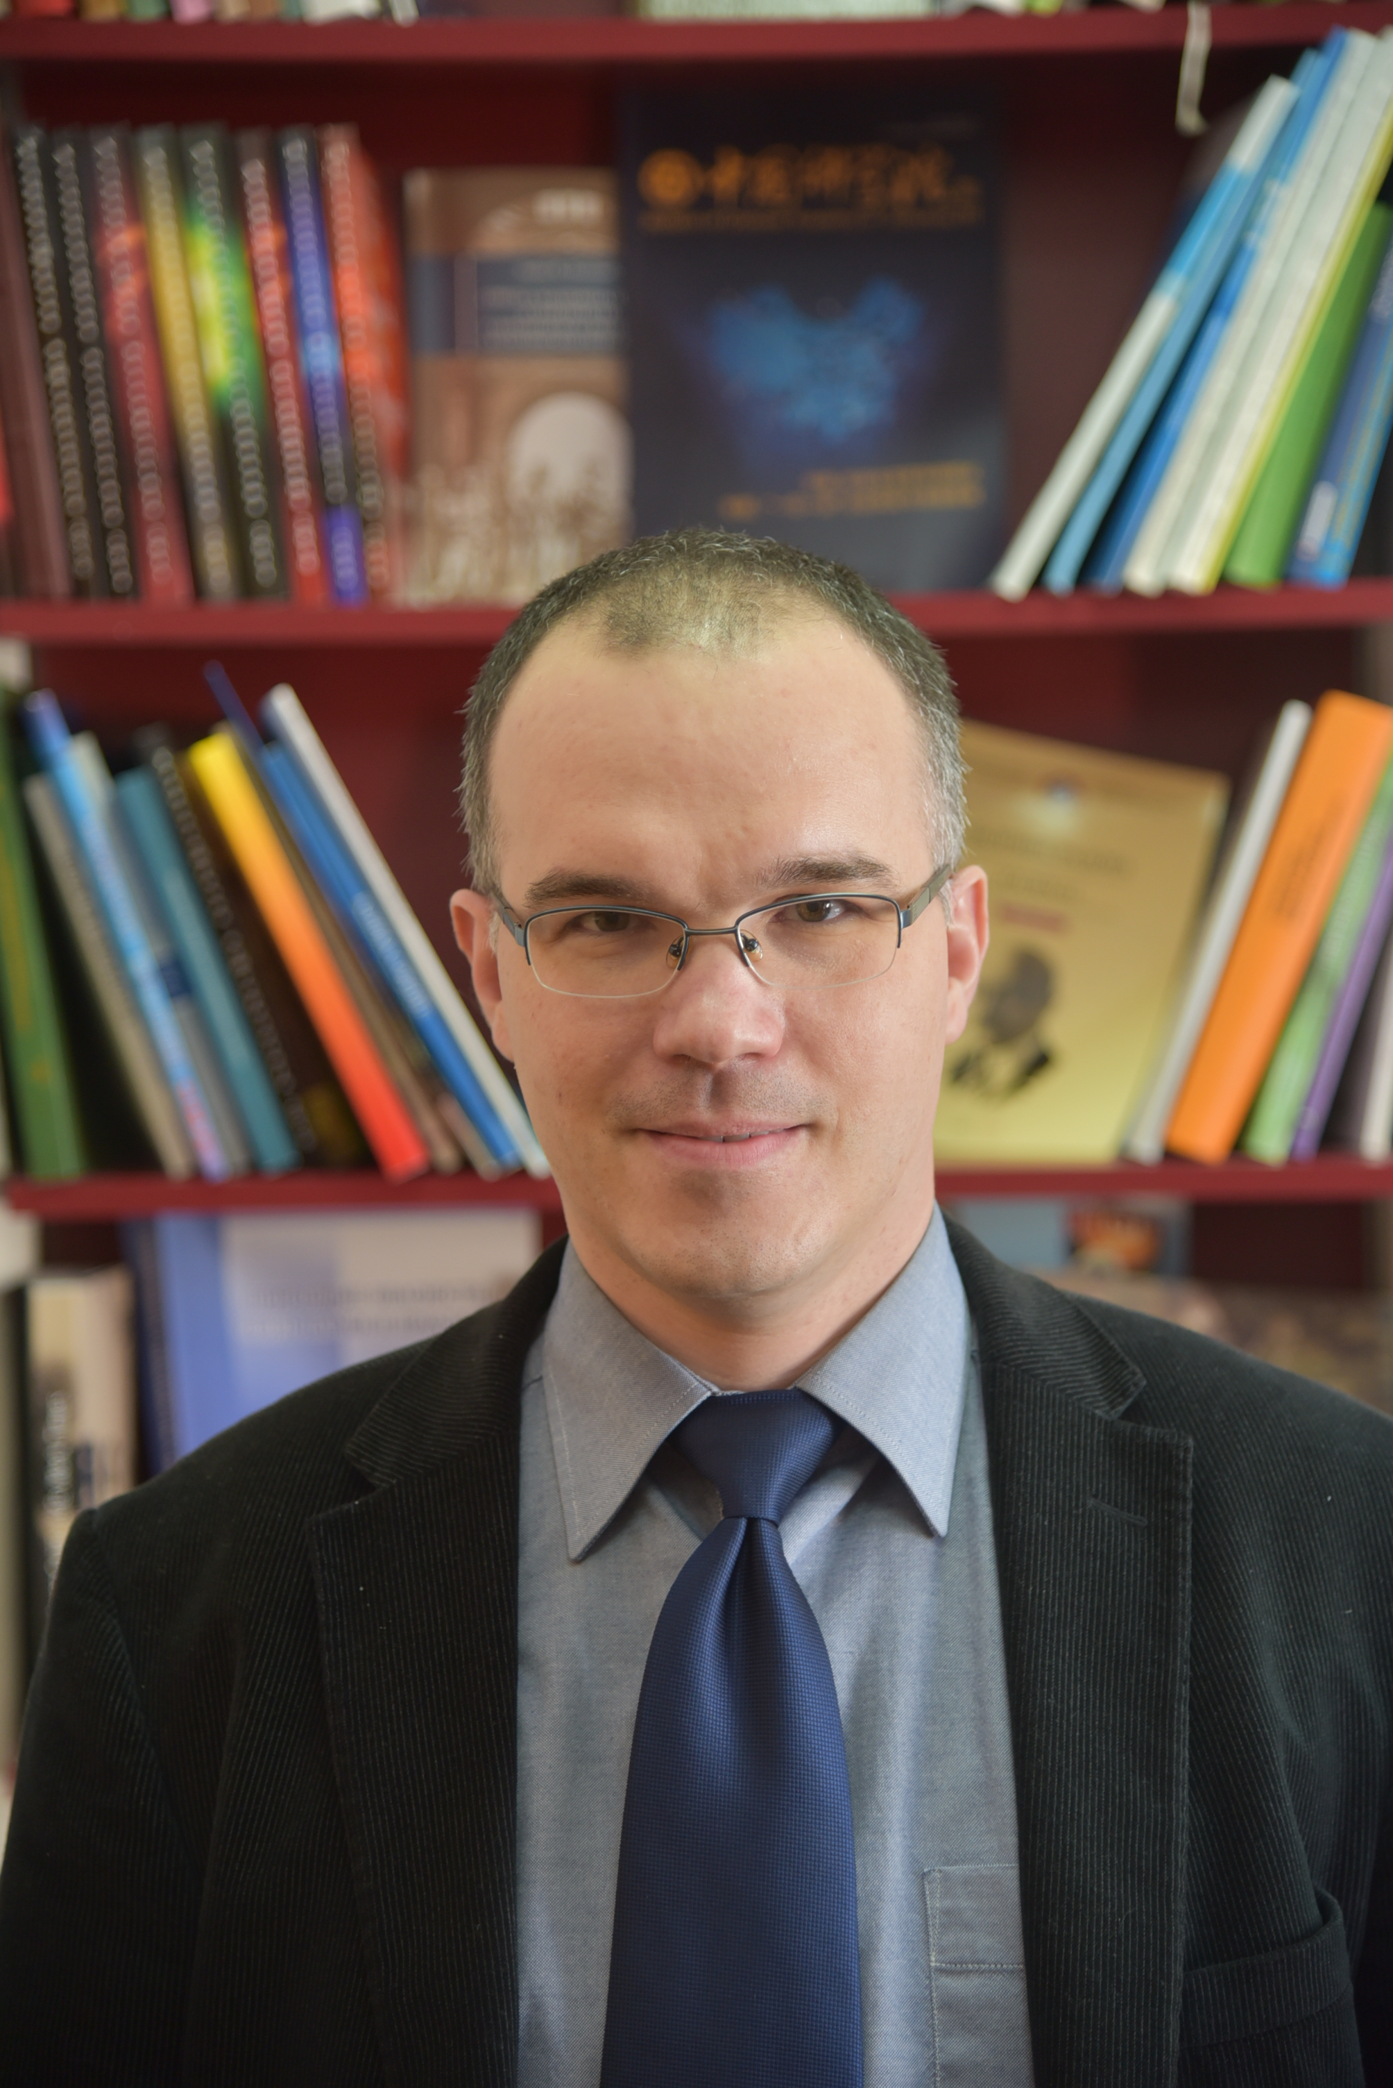

Marko Urošev, PhD
Research Associate
Geographical institute “Jovan Cvijić” SASA
11000 Belgrade, Đure Jakšića 9

Phone: +381-11-2636594, +381642763595
Fax: +381–11–2637597
E-mail: m.urosev@gi.sanu.ac.rs, markourosev@gmail.com

Research area
Physical geography, hydrology, stochastic hydrology

Education
- PhD studies: Faculty of Sciences, University of Novi Sad (Thesis: Hydrological droughts in the basin of Velika Morava), 2016.
- MSc studies: Faculty of Geography, University of Belgrade (Thesis: Hydrological analysis of Golijska Moravica basin), 2006.
- Graduate studies: Faculty of Geography, Moscow State University “M.V. Lomonosov”, Russia, 2001.

Employment
- 2017 – Research Associate, Geographical institute “Jovan Cvijić” SASA, Belgrade
- 2006-2016 Research Assistant, Geographical institute “Jovan Cvijić” SASA, Belgrade
- 2003-2006 Scholar of Ministry of science and technological development, engaged in Geographical Institute "Jovan Cvijić" SASA, Belgrade

Published book
1. Urošev, M. (2007). Golijska Moravica River Basin – the hydrological analysis. [in Serbian]. Belgrade: Geographical institute “Jovan Cvijić” SASA. ISBN 978–86–80029–39–9.

Book chapters in monography of international importance
1. Panić, M., Urošev, M., Milanović Pešić, A., & Miljanović, D. (2014). Hydropower development in Serbia: current state, perspectives and challenges. In Lucille Burke (Ed.), Hydroelectricity and Power Electronics. (pp. 1-54). New York, NY:Nova Science Publishers, Inc. ISBN: 978-1-63321-728-7
2. Kovačević-Majkić, Ј., Urošev, М., Štrbac, D., Мilanović Pešić, А. (2013): Torrential floods prevention possibilities – case study of the Skrapež River watershed (Western Serbia). In: Raskovic, B., Mrdja, S. (Eds.), Natural Disasters: Prevention, Risk Factors and Management. New York: Nova Science Publishers, Inc. ISBN: 978-1-62257-676-0

Published articles in international journals
1. Panić, M., Urošev, M., Milanović Pešić, A., Brankov, J., & Bjeljac, Ž. (2013). Small hydropower plants in Serbia: Hydropower potential, current state and perspectives. Renewable and Sustainable Energy Reviews, 23, 341-349. ISSN 1364-0321, DOI:10.1016/j.rser.2013.03.016

2. Gavrilović Lj., Milanović Pešić A., & Urošev M. (2012). A hydrological analyses of the greatest floods in Serbia in the 1960-2010 period. Carpathian Journal of Earth and Environmental Sciences, 7(4), 107-116. ISSN 1842 – 4090

Book chapters in monography of national importance
1. Urošev, M, Kovačević-Majkić, J, Štrbac, D, Milanović Pešić, A, Milijašević, D, Jakovljević, D, Petrović, A. (2017). Waters of Serbia [in Serbian]. In: М. Radovanović (Ed.), Geography of Serbia. (Special issue, vol. 91, pp. 160-235). Belgrade: Geographical institute “Jovan Cvijić” SASA. ISBN 978-86-80029-70-2.

Published articles in national journals
1. Urošev, M, Dolinaj, D, Leščešen, I. (2016). Hydrological droughts in the Južna Morava river basin (Serbia). Geographica Pannonica 20(4), р. 197-207. DOI: 10.18421/GP20.04-02, ISSN 0354-8724
2. Urošev, M., Dolinaj, D., & Štrbac, D. (2016). At–site hydrological drought analysis: case study of Velika Morava River at Ljubičevski most (Serbia). Journal of the Geographical Institute "Jovan Cvijić" SASA, 66(2), 203-220. DOI 10.2298/IJGI1602203U, ISSN 0350-7599
3. Kovačević-Majkić, J., & Urošev, M., (2014). Trends of mean annual and seasonal discharges of rivers in Serbia. Journal of the Geographical Institute "Jovan Cvijić" SASA, 64(2), 143-160. DOI: 10.2298/IJGI1402143K, ISSN 0350-7599
4. Milanović, A., Urošev, M., Milijašević, D. (2010). Floods in Serbia in the 1999-2009 period – hydrological analysis and flood protection measures. Bulletin of the Serbian geographical society, 90(1), 93-121. DOI:10.2298/GSGD1001093M, ISSN 0350–3593
5. Urošev, M., Milanović, A., & Milijašević, D. (2009). Assessment of the river habitat quality in undeveloped areas of Serbia applying the RHS (river habitat survey) method. Journal of the Geographical Institute "Jovan Cvijić" SASA, 59(2), 37-58. DOI:10.2298/IJGI0902037U, ISSN 0350-7599
6. Urošev, M., Ocokoljić, M. (2008). Limiting factors of navigation on the Tisa River [in Serbian]. Bulletin of the Serbian geographical society, 88(1), 117-124. ISSN 0350–3593
7. Urošev, M. (2007). Analysis of seasonal flow and minimum water discharge of Veliki Rzav for the purposes of regional water supply system "Rzav" [in Serbian]. Bulletin of the Serbian geographical society, 87(2),41-50. DOI:10.2298/GSGD0702041U, ISSN 0350–3593
8. Milanović, A., Urošev, M., Milijašević, D. (2006). Use of the RHS method in Golijska Moravica river basin [in Serbian]. Bulletin of the Serbian geographical society, 86(2), 53-61. DOI:10.2298/GSGD0602053M, ISSN 0350–3593
9. Urošev, M. (2006). Water quality in the Golijska Moravica basin [in Serbian]. Bulletin of the Serbian geographical society, 86(1), 55-60. DOI:10.2298/GSGD0601055U, ISSN 0350–3593

International scientific conferences / Publications from international scientific conferences

1. Kovačević-Majkić, J., Urošev, M., Štrbac, Š., Srdić, Z., Miljanović, D. (2016). Problems related to the determination of river network density in Serbia. In Jović, V. & Petrović, M. A. (Eds.) 150th anniversary of Jovan Cvijić’s birth - Proceedings of the International Conference (pp. 99-110). Belgrade: Serbian Academy of Sciences and Arts and Geographical Institute “Jovan Cvijić” SASA.
2. Urošev, M., Leščešen, I., Štrbac, D., Dolinaj, D (2016). Extreme hydrological situations on Danube River - Case study Bezdan hydrological station (Serbia). In S. Erpicum et al. (Eds.), Sustainable Hydraulics in the Era of Global Change: Proceedings of the 4th IAHR Europe Congress (Liege, Belgium, 27-29 July 2016) (pp.771-778). London, UK: Taylor & Francis Group. ISBN: 978-1-138-02977-4.

3. Urošev, M., Milanović Pešić, A., Kovačević-Majkić, J. (2013). Nutrient load of the Danube and its main tributaries in Serbia. In S.V. Sobol (Ed.) [in Russian]. Proceedings of the Congress of the International Scientific and Industrial Forum “Great Rivers 2013”. Volume 1. (pp. 48-52). N. Novgorod: NNGASU. ISBN 978-5-87941-941-2.
4. Urošev, M., & Milošević, M. (2004). Relationship between flow of phosphorus, mean annual discharge and seasonal water flow of the Moscow river. In Jones, J. A. A. & Vardanian, T. G. (Eds.), Proceedings from conference “The rational use and conservation of water resources in a changing environment”, Vol.1, (pp. 144-146). Yerevan: Yerevan State University Press.
5. Radovanović, M., Kovačević, J., & Urošev, M. (2004). Some aspects of researches of the Danube water regime in Serbia under the temperature changes conditions. In Jones, J. A. A. & Vardanian, T. G. (Eds.), Proceedings from conference “The rational use and conservation of water resources in a changing environment”, Vol.1, (pp. 208-213). Yerevan: Yerevan State University Press.

National scientific conferences / Publications from national scientific conferences
1. Štrbac, D., Urošev, M., Milošević, M, Todorović D. (2015). Use of GIS of local self-government in conditions of natural disaster [in Serbian]. Proceedings from the conference “The planning and normative protection of space and environment” (pp. 123-128). Belgrade: Association of Spatial Planners of Serbia and University of Belgrade - Faculty of Geography, ISBN 978-86-6283-023-4 (APPS).
2. Urošev, M., Kovačević-Majkić, J. (2007). Application of the Microstation software in the hydrological study of the basin [in Serbian]. Proceedings of the First Congress of Serbian Geographers, Vol. 1 (pp. 251-255). Belgrade: Serbian Geographical Society, ISBN 978-86-82751-20-5.
3. Urošev, M. (2004). European and our water legislation [in Serbian]. In Đukić, А. (Ed.), Proceedings from the 33rd Conference of the Yugoslav Society for Water Protection "Water 2004", 8. – 11. june 2004, reservoir Bor, (pp. 9-12). Belgrade: Yugoslav Society for Water Protection. ISBN 86-904241-1-3

Participation in projects
- from 2011-. Geography of Serbia (47007 – Ministry of education and science of the Republic of Serbia)
- 2006–2010. Modes of evaluating the geopotential of the underdeveloped areas in Serbia (146011– Ministry of Science and Technological Development of the Republic of Serbia)

Уређивање тематских зборника, часописа и колективних дела
- Technical editor of the Journal of the Geographical Institute ”Jovan Cvijic” SASA, 2010-2013.

Membership in professional associations
- The Serbian Geographical Society
- IAHS (the International Association of Hydrological Sciences )

Other
- In Geographical institute “Jovan Cvijić” SASA (GIJC SASA)responsible for international cooperation with the institutions of the Russian-speaking region: organization of scientific programs on the basis of bilateral agreements with institutions from Russia (Moscow state university “M.V. Lomonosov”, Nizhny Novgorod State University of Architecture and Civil Engineering, Institute of Geography “V.B. Sochava” Russian academy of science).
- Active participation in the organization of scientific conferences, organized by GIJC SASA: international scientific conference "Natural disasters - links between science and practice" (2013, Belgrade); International scientific conference "150th anniversary of Jovan Cvijić’s birth" (2015, Belgrade) and International scientific conference “The Balkan Peninsula of Jovan Cvijić: Historical Background and Contemporary Trends in Human Geography” (2018, Tršić)
- Reviewer of 2 articles for international scientific journal CLEAN - Soil, Air, Water (ISSN: 1863-0650) 2012 and 2013, reviewer for national journals: Journal of the Geographical Institute "Jovan Cvijić" SASA (2012, 2014), Bulletin of the Serbian geographical society (2016) и Geonauka (2014)
- Lecturer on the programme of professional advancement of employees in the sphere of education: „Natural disasters and teaching geography“ (2012-2013) and „ Instrumental gathering of spatial data “ (2010-2012)
- Participant in the Science Festival „No theory“ (2012)
- International workshop “Fresh water assessment: developing tools for classifying and evaluating rivers and lakes for conservation and management”, Novi Sad, National committee of IAD Serbia and Montenegro, 2005.
- Alternative Academic Education Network, Belgrade, Specialist Course: Environment - a challenge for science, technology and society, 2003.

Data provided 12. 03. 2019.

